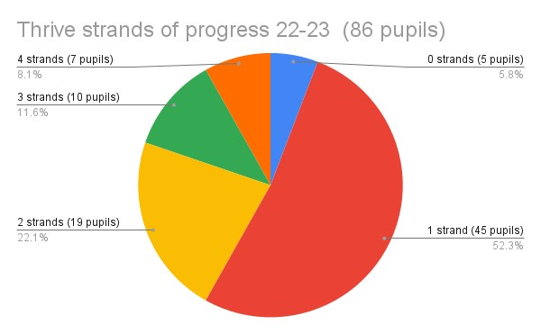

KS1:0 Strands of progress = 2.25% (2 pupils)  1 Strand of progress = 13 (11 pupils)  2 Strands of progress= 9% (8 pupils) | KS2: 1 Strand of progress= 9% (8 pupils)  2 Strands of progress=6% (5 pupils)  3 Strands of progress=8% (7 pupils)  4 Strands of progress=5% (4 pupils)
KS3: 0 Strands of progress= 1% (1 pupil)  1 Strand of progress=7% (6 pupils)  2 Strands of progress= 3.5% (3 pupils)  3 Strands of progress= 3.5% (3 pupils)  4 Strands of progress= 2.5% (2 pupils) | KS4: 0 Strands of progress=2.5% (2 pupils)  1 Strand of progress=14% (12 pupils)  2 Strands of progress=1% (1 pupil)
KS5: 1 Strand of progress=9% (8 pupils)
2 Strands of progress=2.5% (2 pupils)
4 Strands of progress=1% (1 pupil)

